1. Main page:

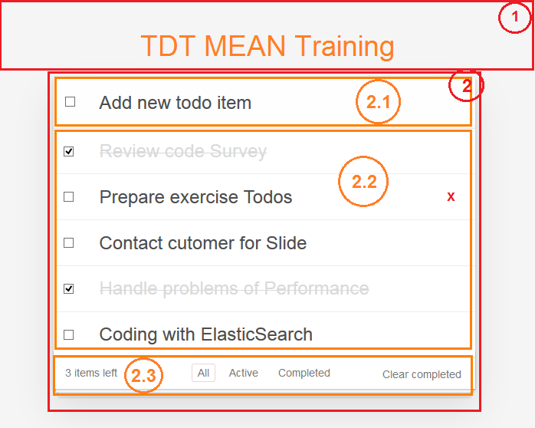

* Header (area **(1)** in above picture):
  + Header contains title, ex “TDT MEAN Training”
* Content (area **(2)** in the above picture):
  + We have 3 sub-areas are **(2.1)**, **(2.2)** and **(2.3)**:
  + Area **(2.1)** – Add new todo item:
    - This is an input area to add new todo item
    - When user click in this input area, and type something, then press “Enter” key, a new item with the typed name will be added to the top area **(2.2)**
  + Area **(2.2)** – list todo items:
    - This are contains a list of todo items
    - If user double-click on item in this list, current item will be switched to edit mode and user able change the name of todo item
    - When user tick the Checkbox in the left-side, item will be marked as “Completed”, user are able to edit status of this checkbox (from Active to Completed and vice versa)
    - When user move over an item in this list, icon “X” will be showed. If user click on “X”, the current item will be deleted (not the same with Completed)
    - Completed items will be show with ~~Strikethrough format~~
  + Area **(2.3)** – Action bar:
    - This are contains number of items in todo list
    - This todo app is a Single Page Application with 3 pages:
      * tdt-mean-training/#/ : When user select “All” in this area. This page will display both “Active” and “Completed” items
      * tdt-mean-training/#/active : When user select “Active” in this area. This page will display “Active” items
      * tdt-mean-training/#/completed : When user select “Completed” in this area. This page will display “Completed” items
    - “Clear completed” text button: When user click on this text button, then all completed items will be deleted